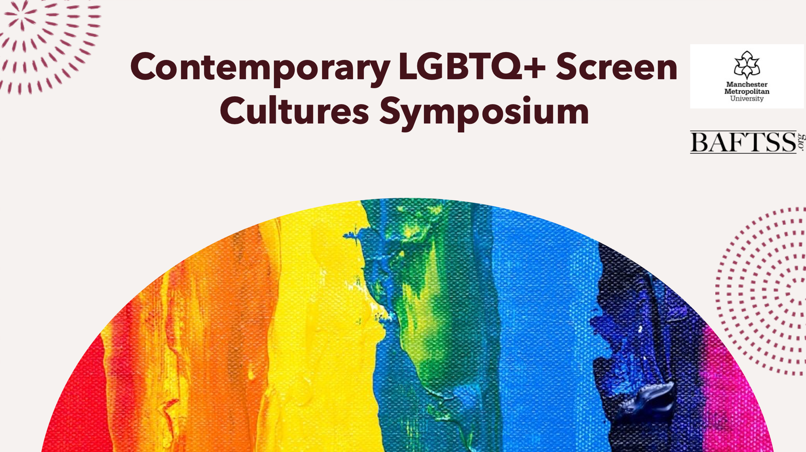

The ‘Screen Studies Network’ at Manchester Metropolitan University hosted its ‘Contemporary LGBTQ+ Screen Cultures Symposium’ on campus on Thursday 25th May 2023. We are extremely grateful to BAFTSS for providing some funding to help underwrite the costs of this event. With funding from our Research Centre too, we were able to make the event free to attend for everybody and provided catering and a number of small travel bursaries to postgraduate and unsalaried researchers. The £300 support from BAFTSS contributed to the general costs of the day (which amounted to £1400 in total).

In a busy day, we had 4 panels covering a diverse range of topics, culminating in a discussion with Greg Thorpe. the Festival Director of GAZE, Dublin’s LGBTQ+ Film Festival. The full schedule for the day is on the link above.

Sam Colling and Andrew Moor, MMU, Department of English.

